***Faculty of computers and artificial intelligence***

**Cover sheet**

**AI330 Machine Learning Project**

**Team no. :**

|  |  |
| --- | --- |
| Name | ID |
| عمر عزالدين قرني عبد الفتاح | 20210611 |
| احمد ايمن جمال الدين علي | 20210029 |
| سيف الله محمود بركات عبد الفتاح | 20210440 |
| عمر طارق محمود محمد | 20210606 |
| عبدالرحمن أنور أنور محمد | 20210494 |
| عبدالرحمن محمد علي دراز | 20210526 |

# Numerical dataset

General information about dataset

|  |  |
| --- | --- |
| Name | Titanic |
| No. of classes | 10 (7) |
| Total no. of samples | 890 (712) |
| No. of samples in training\validation | 570 |
| No. of samples in testing | 142 |

## 

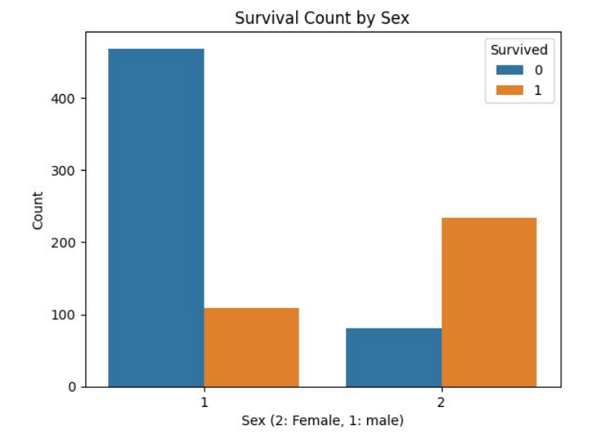

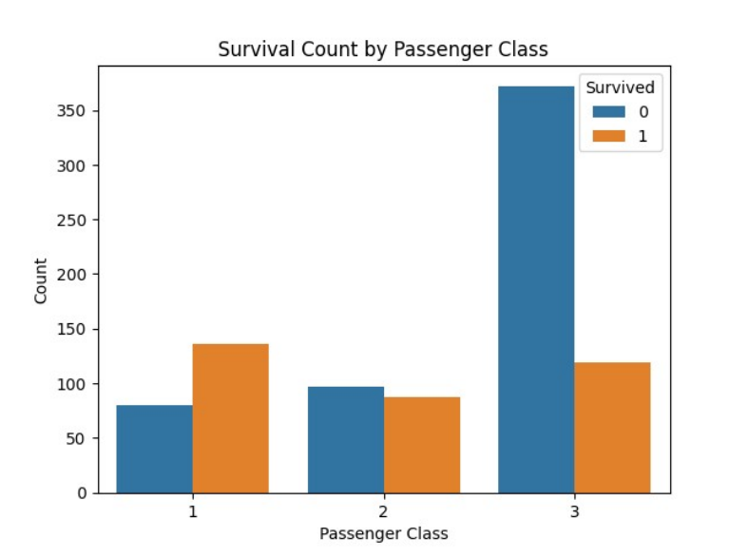

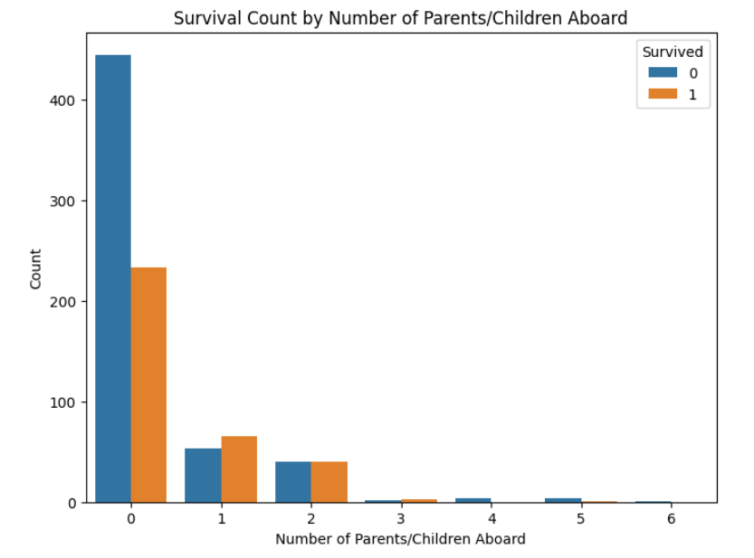

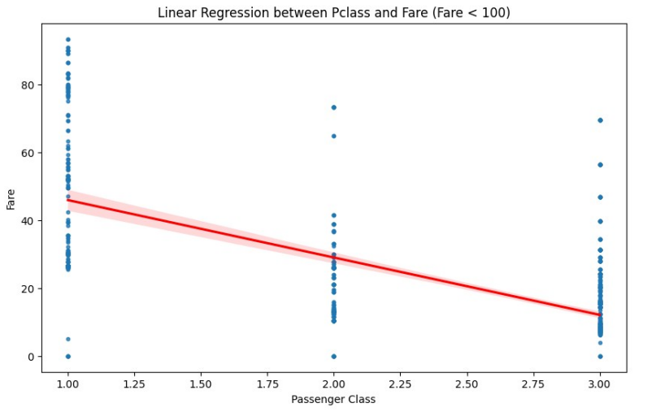

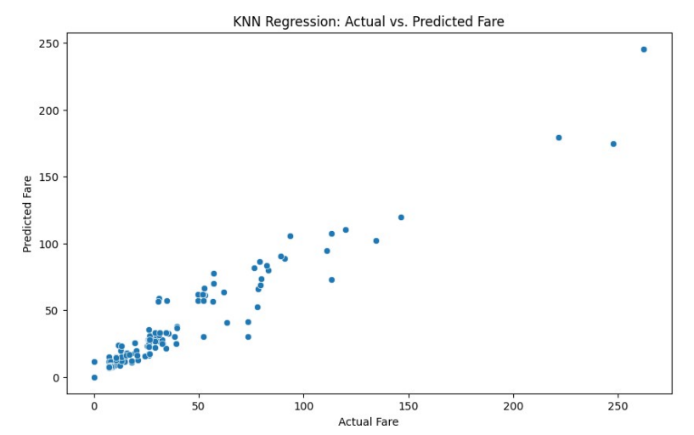

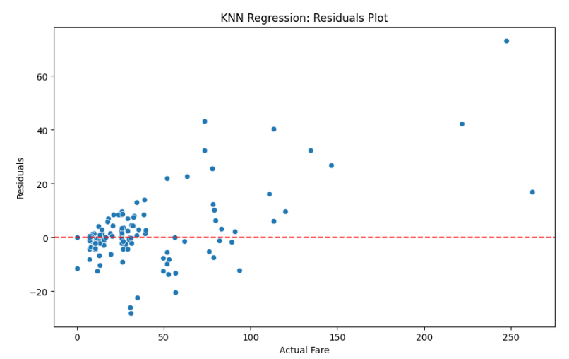

Mean Squared Error: 121.54547820147936

R-squared: 0.921453307681835

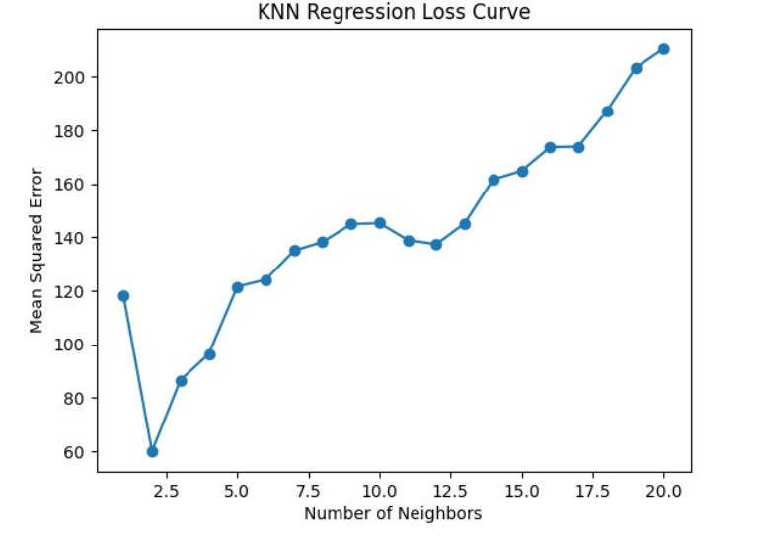

# Image dataset

General information about dataset

|  |  |
| --- | --- |
| Name | Dataset: PlantVillage Dataset |
| No. of classes | 5 |
| Total no. of samples | 3500 |
| Size of image | 256*256 |
| No. of samples in training\validation | 2800 |
| No. of samples in testing | 700 |

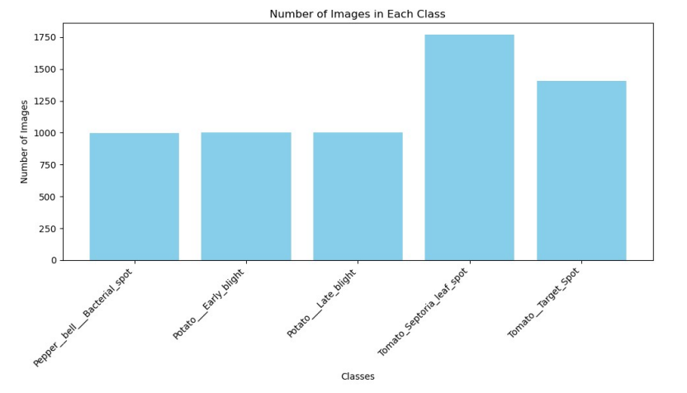

-Implementation details:

No. of features :3500

the dimension of resulted features:  
Is cross-validation is used in any of implemented models🡪 no

-hyperparameters:

Logistic Regression 🡪max_iter=1000 and default values

Kmeans🡪n_clusters=5 and default values

Accuracy: 0.7628571428571429

